**Strategic Machines, Inc.**

**Agreement with Justin Adams**

**June 1, 2018**

**For professional services:**

**Home Page Improvements and integrations**

**Backgrounder on the vision of Strategic Machines**

The novel idea of Strategic Machines is that cognitive applications can be delivered in a short cycle at a lower economic price point by leveraging microservices. The term ‘cognitive’ has become synonymous with ‘artificial intelligence’, and as a result, many static or highly predictable tasks that can be handled through pure functions are being deployed on specialized ai platforms. As a result, complexity and costs mount as companies attempt to create ‘conversational apps’ using highly specialized languages and complex platforms. Organizations are reluctant to adopt. Opportunity is lost.

Strategic Machines is dedicated to the delivery of winsome Brand interactions through standard, open source technologies. We consume ai services where needed but build interactions in a manner that makes it easy to configure, test and maintain.

By engaging customers through any channel with smart virtual agents, we help our clients gain a competitive edge in their respective markets. Microservices is at the heart of the architecture.

As additional context, note the following diagram

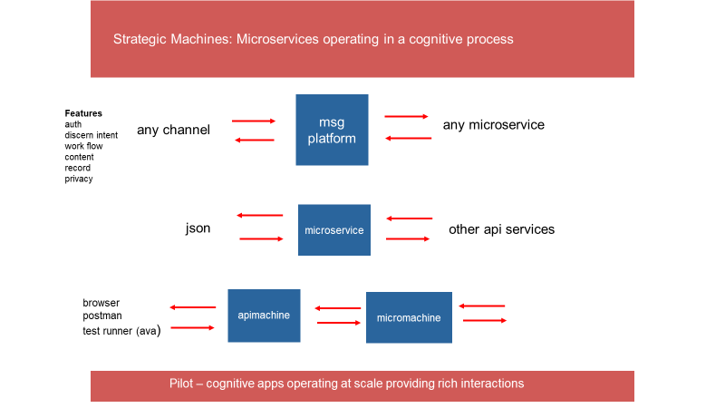

1. The ‘msg platform’ is designed to handle a text message from any channel (slack, sms, fb, telegram, viber etc.) The text message is authenticated, analyzed and passed to a microservice for processing as part of a uniform data object, along with a rich set of additional information that can be used by the microservice to compose responses.
2. The microservices receives a json data object, and processes that data object by initializing a constructor. The constructor (published as an npm package in the future) provides a set of functions for interrogating the value of properties on the data object and returns an array of replies to the messaging platform
3. The apimachine and micromachine are 2 simple servers for use by developers in testing new microservices (not the scope of this workorder – just provided here for information purposes)

The Web Machine platform provides a host of infrastructure services to register networks, join communities and configure agents. As illustrated in this diagram, an agent gallery will enable available bots to chat with a user – by tying into backend microservices through the messaging platform

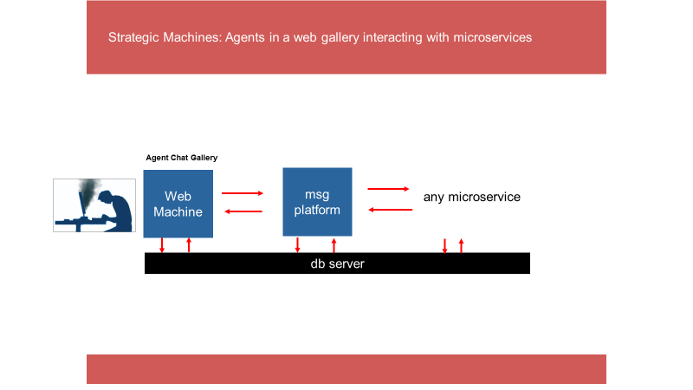

Workorder :

Based on the latest round of refactoring, the reactjs homepage, server route and autho process has been integrated with the webmachine platform. Additional improvements are needed. The requirements of this workorder are as follows:

1. Update the home page and ‘placeholder pages’ (like /about, /product etc. ) to improve styling and looks. Include lorem ipsum text for now as additional placeholders on a page where needed Update the pages so that the footer is fixed to the bottom of the webpage. Complete the look and style and navigation of the pages in a professional manner
2. Update the webchat widget so that it works with the web messaging platform. It should initiate an http transaction to the platform --- and receive and a post a reply --- effectively helping the user to conduct a chat with the ‘Turing Machine’ – the official welcome bot of Strategic Machines. The development of this bot is outside of the scope of this work order – your scope is to work with the api to facilitate a chat (note – Evgheni is building an agent gallery and will also have details on how the api operates. In the meantime, do consult the docs at

<https://github.com/strategicmarket/message>

These docs for this ‘constructor’ are a work in progress – so they will be updated as time progresses. Note that the general flow of your http transaction would be from your web page to the webmachine server – which would use the constructor – to create the data object for sending to the messaging platform and to consume the data object received (hopefully improvement in the docs will help illustrate this – otherwise call me to discuss)

1. Final requirement is to add to the homepage inviting visitors to our slack channel. Below are sample open source projects that you can use or reference for this page and its operation. Ultimately, this ‘slack signup’ page needs to be integrated with the webmachine platform –

We will need to open a new strategic machines slack account for ‘clients’ to join --- so let me know when you want me to set that up for you

* 1. <https://slackin.now.sh/>
  2. <https://github.com/rauchg/slackin>
  3. <https://github.com/outsideris/slack-invite-automation>

------------------------

In addition to the set of requirements outlined above

* Demonstrate disciplined and well-organized coding techniques for all modules delivered. Ensure that code is well structured and commented
* Tests will be included as part of this deliverable
* Code will be delivered through pull requests on the ‘strategicmarket’ github site consistent with the codex.
* Expected delivery date of final deliverable is targeted for no later than June 16, 2018.
* You agree that this is work for hire, work will be done in a quality manner, all deliverables are owned by Strategic Machines, Inc, and the work or concepts will be treated confidentially and not be disclosed to another party without express written permission of Strategic Machines
* This work order can be terminated by either party at anytime

**Payment:**

**$500.00**

upon delivery of this tested application. Any specific instructions for the operation or configuration of the web page should be delivered as part of README file inside the directory for this app.

Your signature on the line below indicates your agreement to the scope and terms of this work order.

Keep 1 copy of this signed workorder for your records and return 1 copy to Strategic Machines

Agreed to:

Date: